# Overall

1. You are not following the advice I have been giving you, especially in areas of bad notation in the literature that I am trying to not propagate. I am especially surprised that you are following bad notation since you get it at the software level (simply put: your software implementation does not follow your notation). Example: **thetaijk** vs. **thetaijb** on page 5. We have discussed this for more than a year. I have shared the book draft with you; all you had to was to read the relevant sections. There is no evidence in your write-up that you have read any of the sections of the book.
2. Your mastery of the software is not matched by corresponding mastery of writing it up. Just as writing code requires great precision, so does writing it up. From the number of edits, and the amount of time it has taken to come this far, it makes more sense, at this point, for me to write it up. I need to find something different for you to do as otherwise we are both wasting time.
3. If we are going to work together effectively, if you disagree, give me good reasons (instances of past inconsistent notation in the literature are not good reasons); *ignoring my attempts at improving the notation is not a good sign for successful collaboration between us*.
4. In hindsight it was a big mistake to let you go alone using the Latek format for so long, which I could not monitor. Converting the paper to Latek should be the last step; we have lost several months as a consequence of this mistake.
5. Just before section 3.2, you refer the reviewer to the help page for this software. This paper is supposed to be the user manual for the software; why does it need an additional help page to complete it? Given there is no page limit the current lack of details is surprising. *A user manual is meant to help the end-user use the software, and with open source software, to also help the R-savvy end-user improve upon it.* Currently there is nothing on data input format, etc.; read the JAFROC and the DBM MRMC readme files; your documentation should have at least that level of detail, *and it needs additional details about the code*.
6. There are problems with the scientific notation, overall organization, and grammar. Even within the limits of simple ROC testing with trapezoidal area as FOM, the current version is largely incomplete.

# Section 2.1

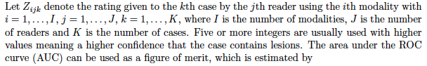

Inconsistent notation: the first equation (unnumbered) should have a subscript on k and it needs an additional t subscript. This notation is all over my current papers and book. Also, in ROC studies one refers to non-diseased and diseased cases, not lesions (lesions imply limited size, and then localization comes in).

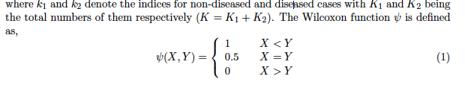

The  function is not the Wilcoxon. It is generally referred to as the kernel function.

# Section 2.2



The reference is to DBM; the reference to jackknife should be Efron etc. book;

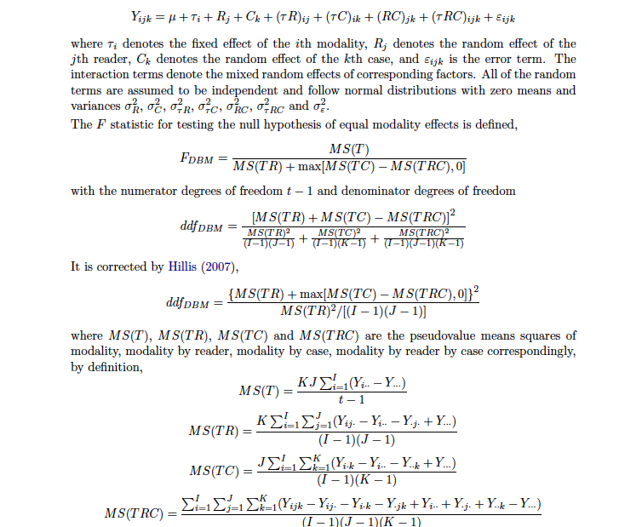

1. The equation for FDBM is not in DBM paper - that paper has 4 rules depending on which variance components come out negative; the single rule form you have is the corrected form by Hillis.
2. You have an epsilon on the rhs at the top of this picture, but it does not appear anywhere below; **Please do not perpetuate bad notation**: (*τRC*)*ijk* + *εijk*: These terms are indistinguishable; just keep the second term; replace TRC everywhere with epsilon.
3. The formulae for MS should have a Y subscript, as in MSY; otherwise you are heading to a notational clash when you introduce the OR method.

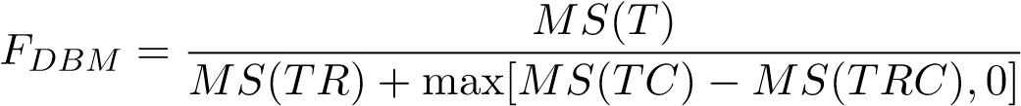

See next comment; this is not FDBM, rather it is the modification suggested by Hillis; should call this FDBMH.

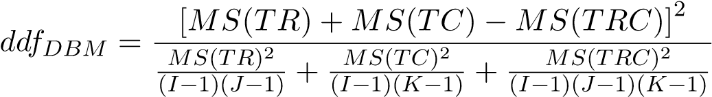 **never used**

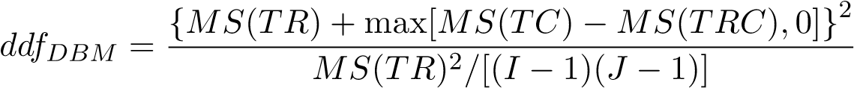

Inconsistent notation; you have two different expressions on rhs for same named variable on lhs.

Second one lhs should be **ddfDBMH**; delete the previous equation, which is never used in the software; just say, DBM ddf as modified by Hillis for better NH behavior.

# Section 2.3

Incorrect reference: Obuchowski Jr and Rockette Jr 1995: Obuchowski does not have a Jr.

*θ*ˆ*ij* = *µ* + *τi* + *Rj* + (*τR*)*ij* + *εij* (2)

The way you have it the last two terms are indistinguishable. **PLEASE**: I have gone over this several times with you; the last term needs a {c} subscript; also on lhs;

DeLong’s method (Hillis, Obuchowski, Schartz, and Berbaum 2005): this is not reference to DeLong's method;

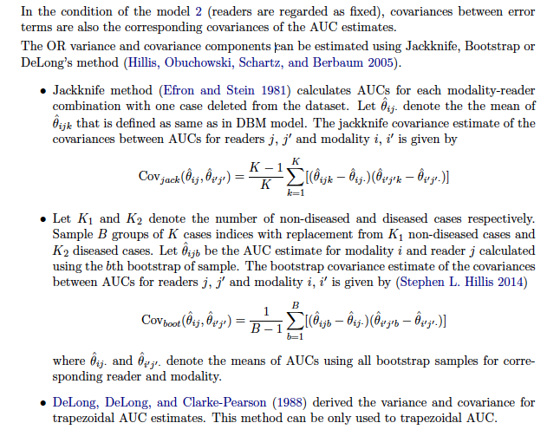

In the first equation, **thetaijk** is not defined (you claim it is defined "as same as in DBM model"; but DBM model has Y's not thetas); *here k is an image index*. This creates a notation clash with **thetaijb** in the second equation, where *b is actually a set of images*, best-denoted {b}, which is the bootstrap realization of the {c} index that I am trying to get you to adopt. See general comment #1.

# Page 5:

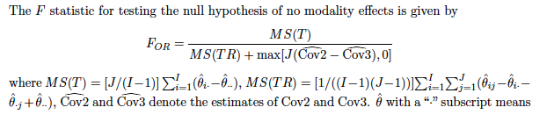

Here is the notational clash that I mentioned before. You are using the same name MS(T) for two different expressions. Please see book.

# Page 6:

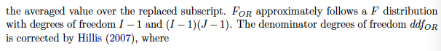

Let us not give conflicting definitions of ddf; do not give (I-1)(J-1), as this is never used in the software; I will need to rewrite this for you.

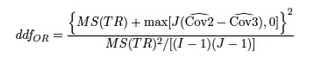

ddfOR should be ddfORH

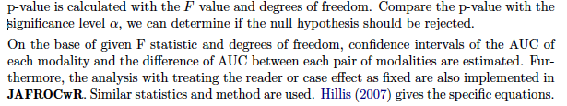

You need to give the formulae for every thing that is reported by the software; that is the meaning of a user manual. In addition, since this is an open source code you need to explain the software.

# 3. Examples and Results Comparisons

1. Kevin Schartz, Berbaum and Hillis sent me the dataset; we need to acknowledge them;
2. The dataset is as an lrc file; use ReadLrc and Writejafroc to convert it to standard JAFROC file format; these steps should be explained in the write up. You cant just say readJAFROC("VanDyke.xlsx") since they did not supply us with and xls file.
3. What is the structure of dataVanDyke?
4. What are the available options for each of the arguments of the DBMAnalysis function? Similarly for OR?
5. You need to go into the functions in more detail; what do they call? That way you can fill up the paper and drop unnecessary topics at this stage. Remember the reviewer will want to understand the code; *currently, you are not showing any code except for the overall calls.*
6. What is the structure of resultDBM, etc.?

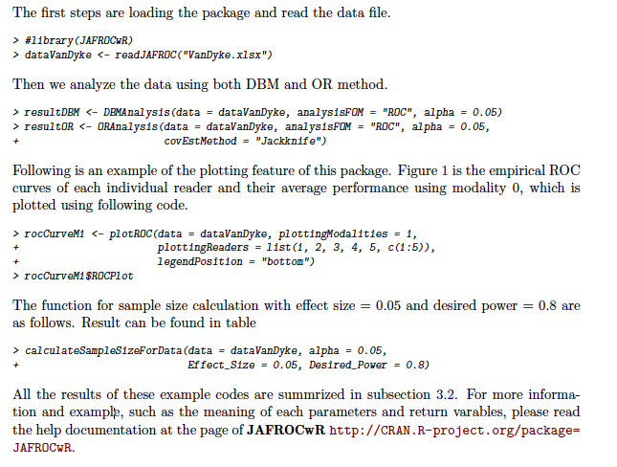

1. Given that we have no page limit, why are you referring the reader to a help page; Otherwise the paper is incomplete.
2. Need details of data input format; how lrc is converted to xls and then read by jafroc.

# 3.2. Results Comparison

The results should be in the same order as the function calls. Show resultsDBM by different methods, then resultsOR, then plots; then sample size.

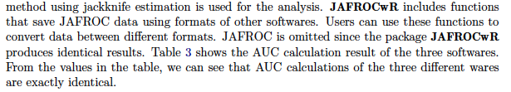

**This is supposed to be a user manual with open-source software**; so you should be telling the users what these functions are; how they are called; what do they return? Show some code snippets, etc. You should be showing how the jackknife/bootstrap are done and how the co-variances and variances, p-values, etc. are calculated. See some examples in my book on how to explain code.

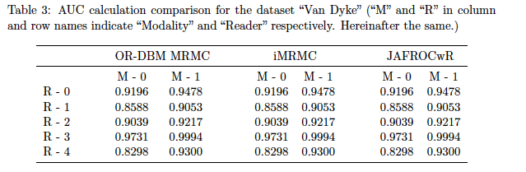

The trapezoidal area is a trivial calculation; we should delete this table and simply state in the text that the values obtained using JafrocR and OR-DBM-MRMC are identical to within machine precision. Also delete iMRMC.

# Page 9

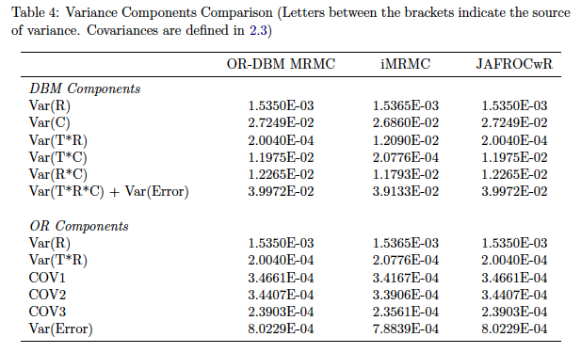

In DBM take out Var(TRC), it cannot be separated from the error term; the OR error term variance has **not been defined** in this paper; you need to say that the OR error term variance estimate is the average of the diagonal elements of the covariance matrix. Take out iMRMC (you don't have an F statistic for them and it cant handle more than 2 modalities; I will refer to them in the Intro/Discussion); need to keep the focus sharp and simple.

# Table 5

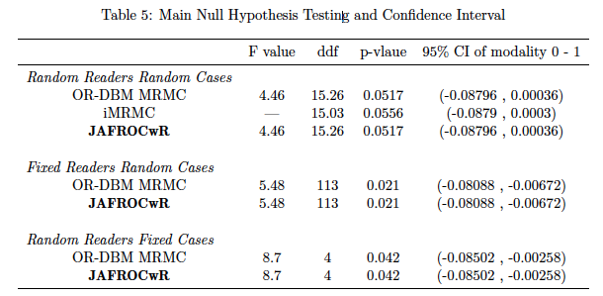

1. Where are the formulae for fixed reader and fixed case analyses?
2. **Please see DBM user manual for minimum level of detail needed. Since theirs is not open source, they do not have to explain their software; we have to also explain the software**.
3. Can iMRMC handle fixed reader etc.? Why is iMRMC row missing in the above table for fixed reader and fixed cases?
4. A column is needed for difference FOM.

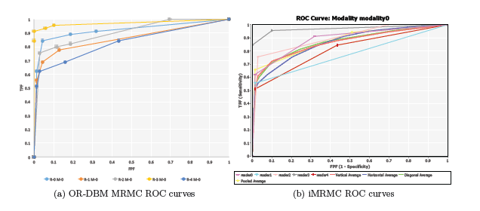

I don't see the point of showing trapezoidal "curves". No curve fitting is involved; comparisons should be identical. They don't look identical.

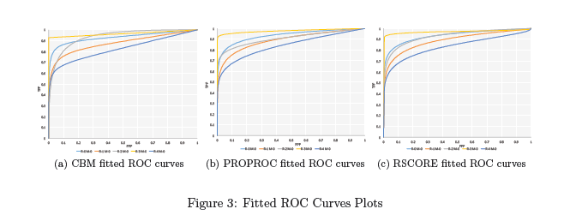

Why show these? we cannot compare to them; I will comment in discussion that these capabilities are currently unimplemented in JafrocR software.

# Table 6

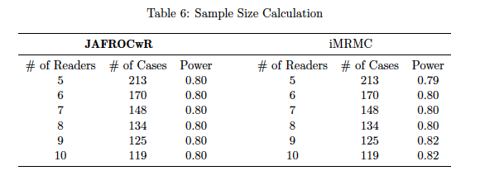

I am not sure sample size is appropriate, except as a Discussion point, since you are currently not doing justice to basic ROC analysis. Also, if kept, need comparison to DBM/OR (SAS), not iMRMC. Their model is different, and you have not explained it.